AUTHORS
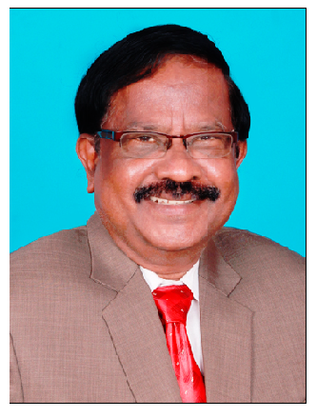
Prof Dr Susai Rajendran PhD(Chemistry), PhD(Education)

Prof Dr Susai Rajendran has been serving the Student Community for the past 45 years as Professor of Chemistry. He is still continuing his research activities in the field of Corrosion and its control, Green Inhibitors, Concrete Corrosion, Corrosion resistance of metals and alloys in various body fluids, Synthesis and Characterization nano particles, Electro organic synthesis, inhibitors for pipelines carrying oil well water … He has received National Meritorious Award in the field of Corrosion, twice, from NACE, India Section. He has authored 10 Books and 3 Patents. He has published more than 300 papers in reputed Journals and produced 40 + PhD Degree Holders. Previously he has worked at GTN Arts College, Dindigul, Servite College of Education for Women, Thogamalai, RVS School of Engineering and Technology, Dindigul, Indial. Presently he is Serving as Professor of Chemistry and Research Director at St Antony’s College of Arts and Sciences for Women, Dindigul. He is an approved guide (Chemistry ) of AMET UNIVERSITY, 135, East Coast Road, Kanathur, Chennai, India. He feels that his students are his strength and wealth. He is standing on the shoulders of his Students. He is taking Research towards the Down Trodden.
“Ruling the whole world is only next to Teaching a Poor Student and making him / her Great”
- He is
- FOR THE STUDENTS,
- BY THE STUDENTS and
- OF THE STUDENTS

